A Model for Contemporary Leadership and Shared Values
A later outlook for the Melbpc Group using a combination of contemporary leadership shared values/experience, underpinned by a strong/transparent (operational) framework which sets direction for a unified achievement involving our members.

Introduction

It is accepted as problematic to go over past failings and especially to criticise an individual member. After all, Melbpc is a group of Volunteers and we are all constantly assessed to have the “best interests of the club” in heart. Yet, we have a recent example, “despite the member’s best intensions”, the group derailed.

After the last SGM, the following comment was posted [1.] (in part)
“But, nothing happens in isolation either.
The environment and recent history and the very way business is transacted has plenty of scope for improvement. This can be seen in the endless opinions and circle debates on Yammer because of the lack of structure, accountability and documentation for both guiding member voluntary contribution(s) and recording factual details (ie MMS failed [details…..])”
Please understand I am not suggesting the basis of the SGM/Members Petition was poorly defined or unjustified. It wasn’t. It was a very difficult time, for self-included, many would prefer to forget.
However, “it takes two to tango” and the environment (in my humble opinion) is complicit and elephant in the room.
Rather than list out shortcomings, the following pointers are offered how to achieve the best from the membership through engagement, capitalizing on diversity, cultivating an open culture of shared values and a clear transparent direction known to all.
The suggested implementation is laid out as a Change process. Of course it is up to the membership how they wish to go but please be mindful, single elements alone will not guarantee a successful or sustainable outcome.
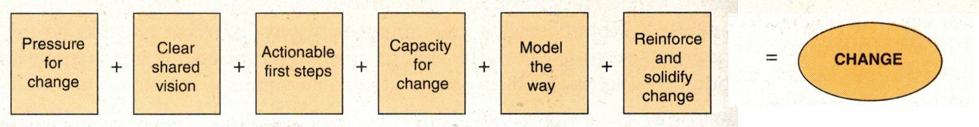[2.]
Short of doing a member survey, let’s take “Pressure for change” as a given and move on to the next step.

Create a Clear shared vision

Though the following actions:

- Bring to the forefront two key documents for member access, consumption and frequent referral (SIG and Group Leaders in particular). This is the Committee’s last approved PLANNING documents for Melbpc specific to direction.
- MELB PC MEMBERSHIP AND MARKETING PLAN UPDATED JAN 2014 – by Lance Lloyd,
In Confidence document presented to the Committee of the day.
- The Preferred Future for Melbourne PC Users Groups Inc – by Bill Ford, PC Update Newsletter October (v2) 2015
A number of initiatives listed are already implemented (i.e. strengthening the SIGS and use of Social Media such as Facebook). “Newsgroups” was marked for expansion but now defunct - replaced by Yammer? The best honour we can give back to contributors of these documents is to elevate their importance out of the closet as core guiding and directional planning material.

- As an open-to-all exercise, collect, assemble and adopt a shared set a VALUES of what it means to be a member of Melbpc. Second only to the directional PLANNING documents, VALUES tell each other, our partners and potential New Members, how we behave and wish to be treated.
Here is one example (service provider) clearly stating desired “norm” as the benchmark
Our values provide direction and clarity about the way we make decisions, work together and achieve our goals.
We put people's health and safety first.
- We build value for our partners and customers through innovation and outstanding service.
- We behave with honesty and integrity.
- We work together, respect each other and value our diversity.
- We are accountable for our actions.
- We are committed to creating a sustainable future.
Our values underpin everything we do, from the way we offer service to our valued customers, to the way we go about our work.

Actionable first steps

- Less of this [hierarchal, top-down]
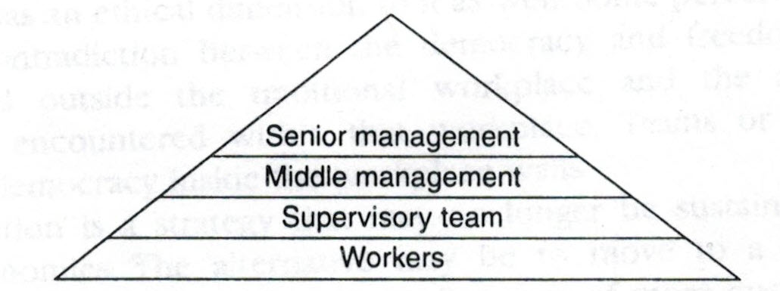 | In addition to the positions specifically included in the Rules, include follow titles: Executive (4), Portfolio positions (# varies) and a Project Manager.
[3.]

More of this – a functional structure orientated to mirror actual operations & activities.
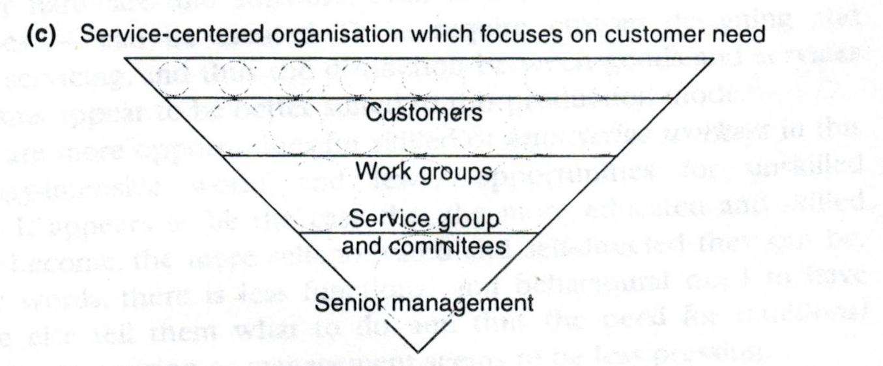[3.]

- Adapt a Melbpc code of Best Practice Principles as a foundation guide in all core operational matters. (Recommended set for Melbpc from 9000 series - eight Quality Management principles.) [4.]

Principle 1 – Customer focus
Organizations depend on their customers and therefore should understand current and future customer needs, should meet customer requirements and strive to exceed customer expectations.
[Note: Customers can be external and internal (group to group, member to member). Think of “iHelp”, Admin, but also anybody and everybody “helping each other”]

Principle 2 – Leadership
Leaders establish unity of purpose and direction of the organization. They should create and maintain the internal environment in which people can become fully involved in achieving the organization's objectives (and their own. SL)
[Note: A core objective of the Committee and leadership]

Principle 3 – Involvement of people
People at all levels are the essence of an organization and their full involvement enables their abilities to be used for the organization's benefit.
[Note: Think of: - Inclusion, Engagement, member Satisfaction, Contributions, Sharing the work, active & informed Ambassadors promoting Melbpc every opportunity]

Principle 4 – Process approach
A desired result is achieved more efficiently when activities and related resources are managed as a process.
[Note: Applies equally to Service organizations. Knowledge of process and shared trust are the hallmark of operational essentials

Principle 5 – System approach to management
Identifying, understanding and managing interrelated processes as a system contributes to the organization's effectiveness and efficiency in achieving its objectives.
[Note: Think interdependence between key areas, a guiding framework and a support environment with the tools necessary to enjoy the experience/succeed with tasks]

Principle 6 – Continual improvement
Continual improvement of the organization's overall performance should be a permanent objective of the organization.
[Note: Ask why has this happened? What can be done to prevent a repeat?

Principle 7 – Factual approach to decision making
Effective decisions are based on the analysis of data and information.
[Note: President George Skarbek masterly demonstrated this looking for source of excess power usage]

Principle 8 – Mutually beneficial supplier relationships
An organization and its suppliers are interdependent and a mutually beneficial relationship enhances the ability of both to create value.
[Note: For example partnering with Microsoft Australia, U3A, Local learning centres, Disability Support Services, Government, etc]

- Provide Direction to the full membership through promotion and explanation of the relationship between:
  - VISION: where we are headed
  - VALUES: what we stand for
  - MISSION: How we’ll get there
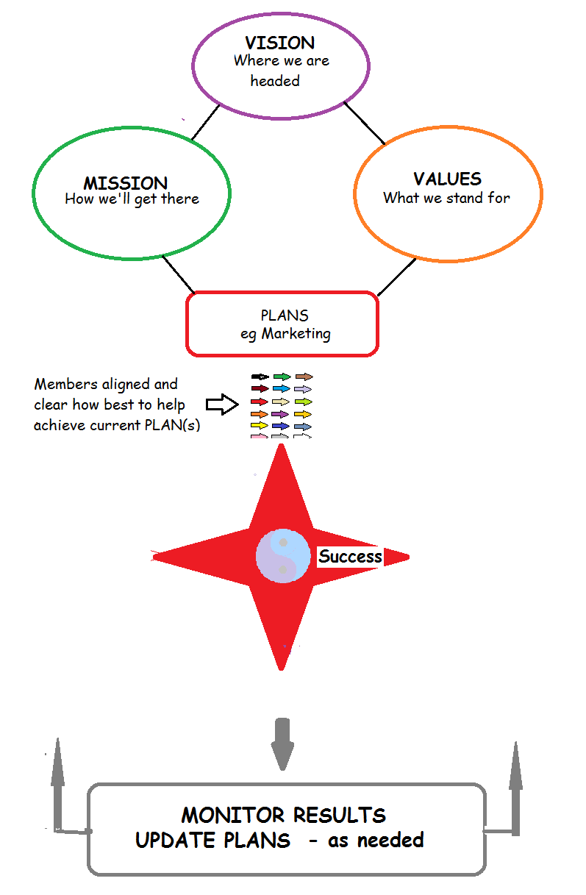

- Acknowledge and formalize a set of core Groups which constitute “Melbpc”, broadly categorized into either Functional (such as Admin, iHelp) or Product interest based marketable activities to engage current members and seek new members. This will require considered assessment and recognition of tasks undertaken by all. The aim is to find a representational set of core Groups peripheral to, but including the Committee.

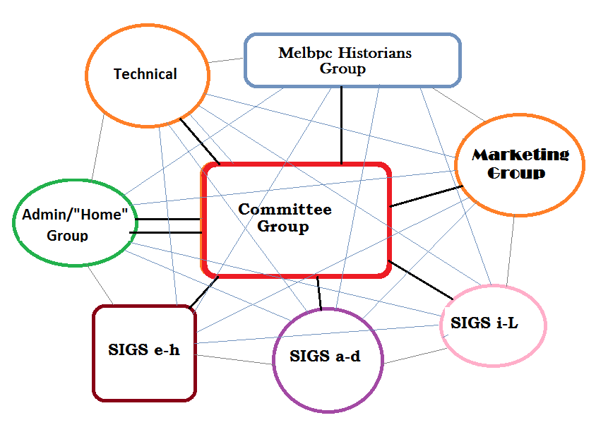

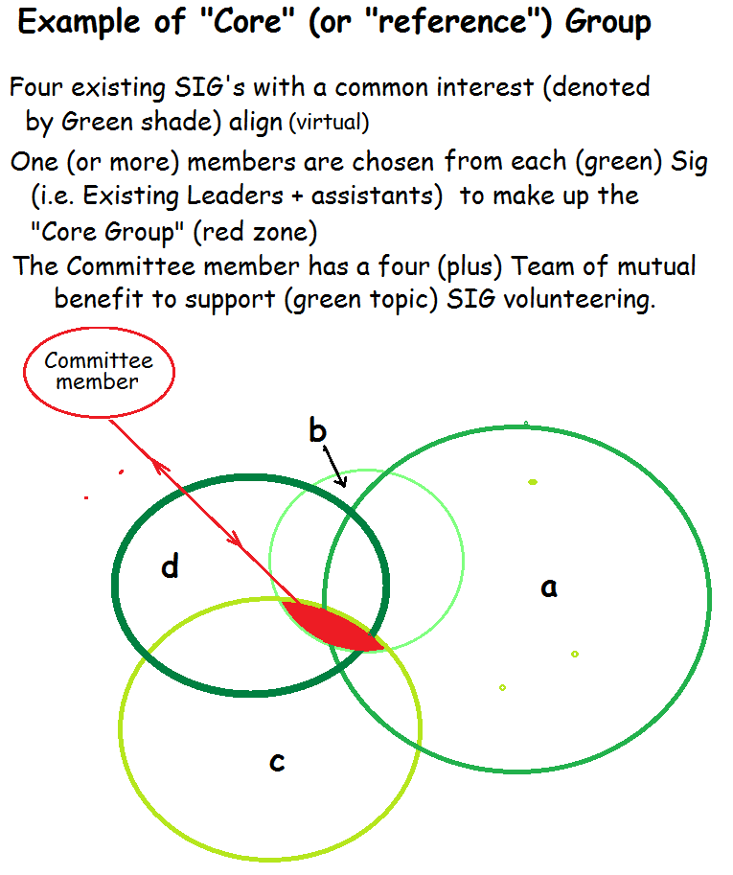

- Construct a model group platform detailing process, tools and relationships to achieve shared vision and goals for all to follow. For example:

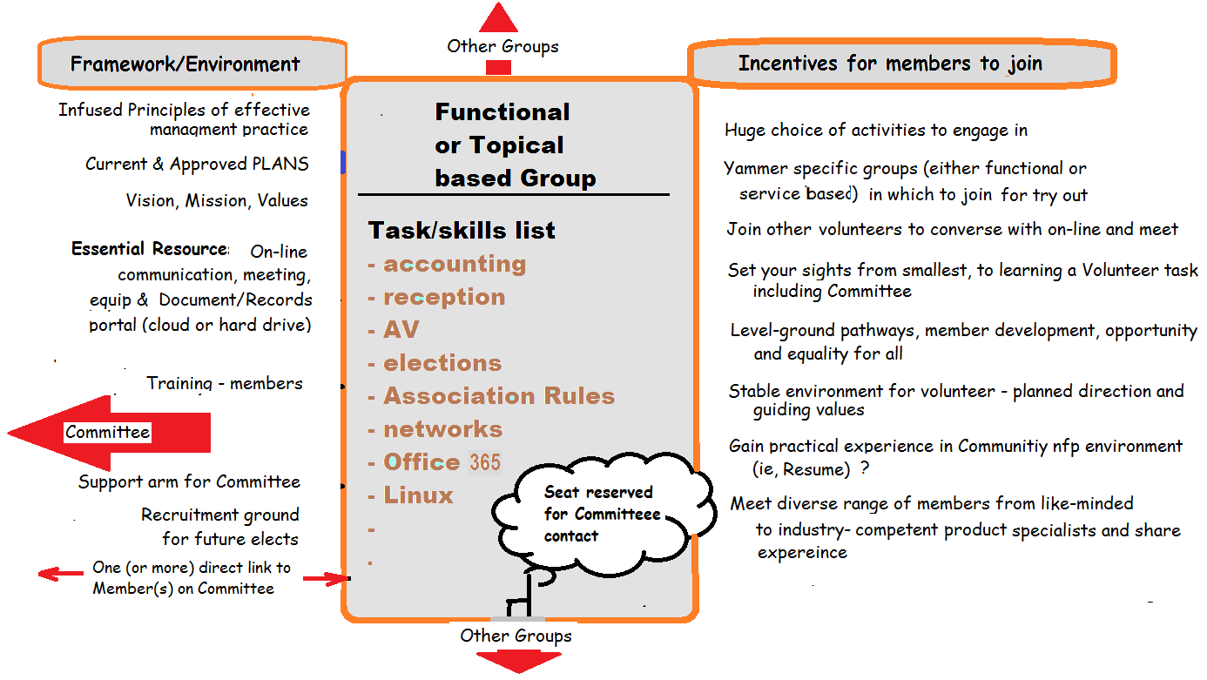

- Adapt/adopt the following guideline to underpin creation and disbanding of core Groups, when and as needed in Melbpc.
  - Core Groups are established to identify and acknowledge core functional (operational) requirement(s) and key marketable-based interest areas. Perhaps they can be considered “Reference Groups” to help delineate from instructive sessions provided on a product where participants just want to learn. [After graduation would be a good point to include them in the mail-list of a core Group as an avenue for volunteering].
  - It is envisaged the Membership will find a suitable mix covering peripheral SIG’s to say five (5) core Groups across Melbpc.
  - Each of the five core Groups will be aligned with one (ordinary) Committee member. It will form a mutual benefit partnership with the Committee. For the Admin/Home Group, two direct contacts with the Committee are likely necessary – Secretary and Treasurer.
  - Group leadership has responsibility to:
    - impart core directional Plans from the Committee, demonstrate due diligence modelling Melbpc core values and help the Group achieve specific goals, as agreed.
    - Inherent in this task is to foster individual member development, seek to freely provide them opportunities and give them ample encouragement to actively assist in as many areas they wish to be involved in, including just learning and for familiarization.
    - The emphasis at all times is engagement, participation, sharing and trust (these are example “Values”) so members genuinely understand their contribution is needed and feel part of the team.
[The practice of holding back opportunities (if done and assuming unjustified), will only serve to stifle the Groups potential for unleashed progress and is not in the best interest of the Club. Cause needs to be fully understood consistent with Group values for “win-win” advancement. If it is about sandcastles, the solution is simply to provide more opportunities to share in the mound and bury the ego.]

  - Groups run autonomously as a service and interdependent with other Groups when specific skills are needed including supporting the Committee.
  - Groups create their own documentation records and procedures for sustainable and transparent operation. From a volunteering and management perspective, this ensures all relevant history and current operational info is available as a basis for training and future advancement of the Club.
  - It is the Committees Group responsibility to provide the necessary unifying tools and resources to achieve point (above), including storage of data and paper records in places solely under the control and security of Melbpc.
  - Core Groups are a natural source of potential future Committee members, including provision to stand-in when member is on leave. This will provide continuity of operations and no imposed delay despite it all being voluntary. Importantly the operations of the Group effectively become the “memory” of how tasks are carried out day to day. This ensures continuity of Melbpc direction despite changes in elected Office bearers and movement in members. It also serves to support new incumbents getting up to speed in their new role on the Committee.
  - Groups can organise their own workshop events and bring in outside expertise for a particular purpose once Ok’d by through their committee incumbent. For example a Marketing workshop inviting all members to share ideas and assist in updating the PLAN.
  - Groups must be provided with assistance where needed to form an effective team and trust each other. This could include exercises in team building, conflict resolution, brainstorming and identifying non supportive behaviours and tactics to bring back to focus.
  - The success of Groups needs to be promoted (such as being invited to make a presentation at a GM), as evidence to all members of activities and fun that can be had being involved. .

Managed properly this arrangement is a win-win for the Committee to have a direct link for expanded duties, recruitment and information seeking, whilst Groups can play a major role in responding to broader membership needs where the action and guidance is paramount at the customer coalface.

Capacity for Change

- Refers to the resources and skills necessary to implement moving to a shared transparent operation and journey for all. Since the proposal involves open planning for improved and responsive coordination, the necessary changes may well drive themselves through member’s new found values, inherent sense of importance to the task and genuine belief being part of the team.

From a Committee perspective, the following realization is likely
- Achievability, compared to current grief, overwhelmed and sensitively to those who don’t know what the Committee is doing. This change will address this.
- More members will be willing to stand for Committee work due to the follow factors”
  - A working environment has been established
  - “Values” – which model our preferred behaviour towards each other
  - Fast interfacing with core Groups and a structure provided, set for the task
  - Opportunity for volunteer backup especially during peak workload. Individuals will be familiar with Group areas of speciality and process, plus goals.
  - Greater task satisfaction – especially when the entire Club appears to be facing the same direction. What a blessing that is.
  - Greater capability to handle respectful conflict to get the best out of members rather than tag as being different.
  - If a partner is present, a benefit for both can be expected
  - Untold appreciation from your fellow members giving permission to be genuinely “on the team”.
  - An elephant stamp from the author when change is successfully implemented.

Model the Way

- Some aspects can be implemented immediately but others would best be “pilot modelled” on a particular project designed to demonstrate implementation, together with needed resources. Perhaps time has approached for a revised Marketing plan for example. Whatever method or opportunity chosen, it is important to appreciate steps missed in implementation can have consequence. Various examples are illustrated below.

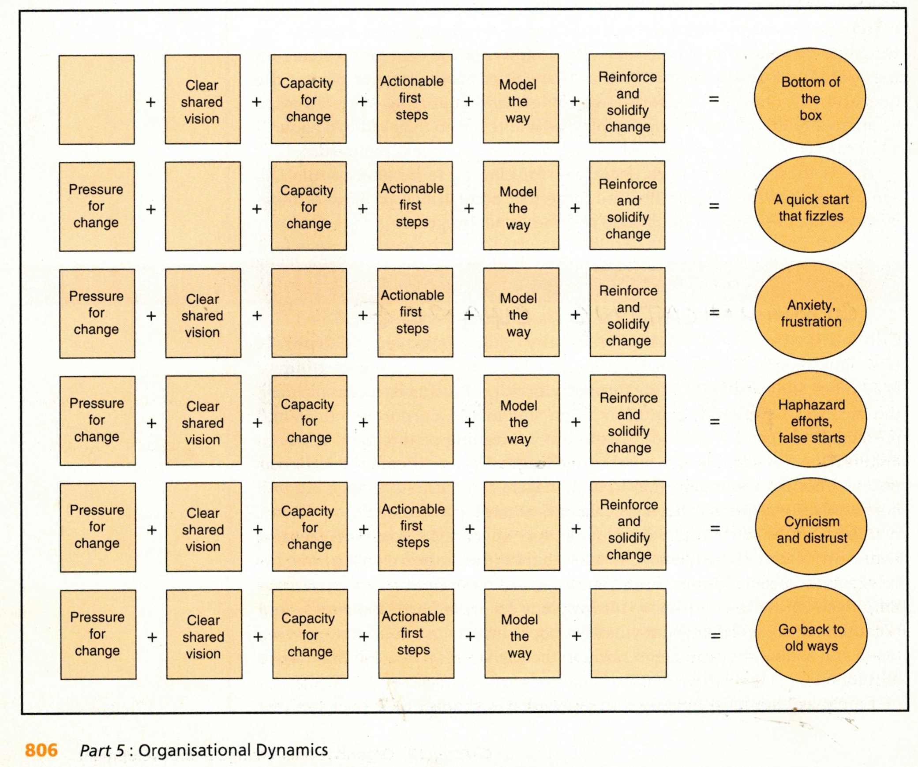[2.]

In conclusion:

Clearly, for an Association the size of Melbpc and its complexities, topped by a broad range of members skill base, diverse views and interests, it is a formidable task to run it to everybody’s satisfaction and your own.

In my own experience the hardest task has been to source information and seeking to understand the history without misinterpreting situation. [hence suggestion “Historians Group” re model supporting the Committee - map out into one place a succinct history of the Club for others to appreciate.]

As far as the ISO9000 standard is concerned, it was formed globally by the International Standards Organisation (ISO) own “SIG’s” group representing minimum standard best practice in Manufacturing and Service scenarios. There are similar standards for Health Services for example. The set chosen here is well out of date but quite suitable for Melbpc, essentially a “service” organisation where it just happens the actual customers are also the Members so we do have to look after ourselves.

I am not proposing adoption, other the basic AWARENESS of the Principles as something to post on the wall for a reminder particularly at Committee and Core group level. Managing by fact is a prime example – obvious in approval of large expenditure but also a basis for conducting Member Surveys routinely and further Market research.

What I hope to have shown is with a group of this size and diversity it needs to have a visible framework, planned direction known to all and in particular a set of behaviours (the values). It is the Values which are a key to promoting the Club in addition to the “doing” (ie Purpose) and significantly acquired knowledge held by our members.

Once established we will all work to unison with a well-earned sense of optimism for the future and the role we play.

Steph Lancaster.
20 Oct 2017
Member Melbpc.

Note: If you are interested in these concepts and would like to share own experiences feel free to write to the Editor or email me directly on stephlan@melbpc.org.au I would be particularly interested in your ideas of what you value in being a member. Perhaps we can make a list to be part of the Clubs Marketing pitch seeking new members. SL

References:
[1.] Yammer group “MelbPC Discussion” S. Lancaster November 3, 2016
[2.] Robbins, Stephen P., Organisation Behaviour: Concept, Controversies and Applications, Prentice Hall 1994
[3.] Eunson, Baden. Communications for Team Building, John Wilely & Sons 1994
[4.] various inc https://en.wikipedia.org/wiki/Quality_management

