Beast Report - 17 July 2016 Dave Botherway

Usual welcome: Usual attendees, plus new member (Welcome Richard Cowan ) . . .

Questions answered were :

How to recover from a CyberLocked ransomware attack – by Image recovery !

Setting up for a Clean Install of Win-10 - preferably, after an Image Backup

Problems accessing Internet after reboot – possibly a DHCP timing issue ?

Office 365 Email – how to sequence multiple accounts, referred to iHelp team

Scam warnings :
- Further examples shown, including one directed at SES members ….

Interesting Information
- Website showing top-25 Most-used passwords . . Curiosity question - how did they capture that info ?

Main Topic
- Zip (and RAR) files – what are they ? ( PDF of presentation attached to August meeting email reminder )

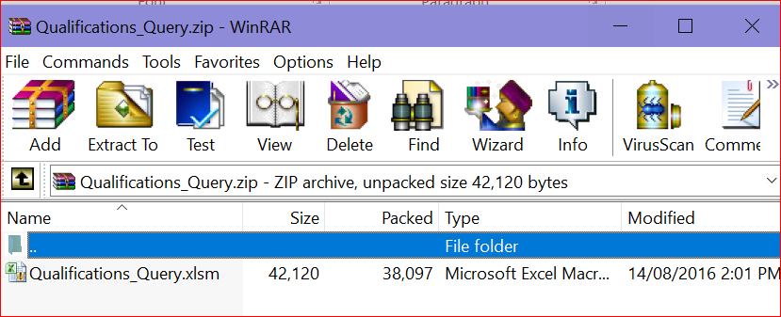

- Demonstration of various ZIP files, and reasons for Zip use . . plus how to Create ZIP files, including Password protection where needed.

Next Month - Suggestions sought . . .

