Beast Report - 19 June 2016 Dave Botherway

Usual welcome: Usual attendees, plus two new members . . .

Buying :

saveonit.com.au - as useful website to find PC bargains . . . .

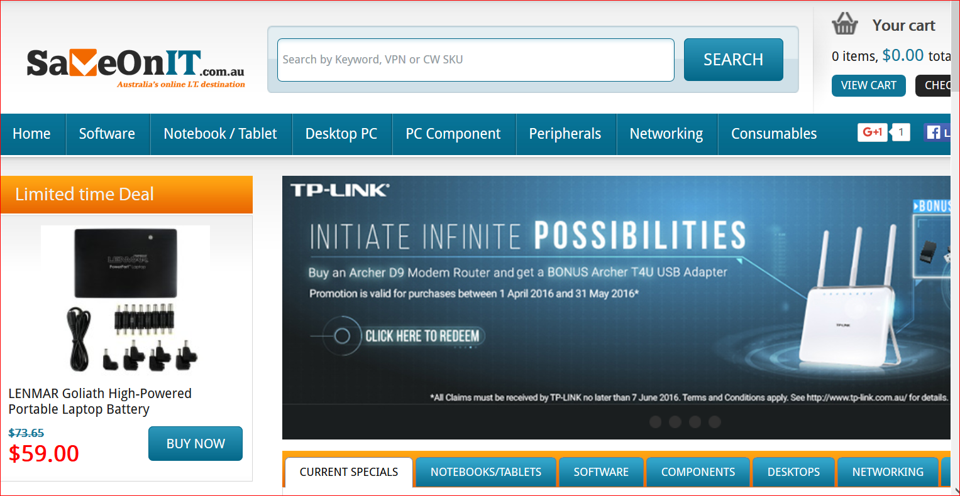

Questions answered were :

Changing Display properties when moving from 4x3 to 16x9 monitor

Setting up Win-10 libraries (especially Pictures) to a non-system drive

Transferring Google Earth placemarks from Desktop to Laptop for travel

Firefox problems accessing regular site (but OK with I-E or other PCs)

Scam warnings :
- Bogus invoice reminders – directed to Small businesses, containing Ransomware

Interesting videos
- Explanatory video from ABS re Online Census responses and privacy issues
- Picture Display showing “someone cares” - ie. ATO

Main Topics
- Ransomware : What is it ? Prevention ? Bit Coins ? Recovery Options ? ( PDF of presentation attached to July meeting email reminder )

- Windows 10 conversion progress

Next Month - Windows 10 - Final Options ?

