Beast Report - 20 November 2016 from Dave Botherway

Apologies from Clive Barber (away on Leave) and Bryan Paten (in Hospital).

Committee Elections – VP = John Hall, Committee= David King, Margaret A Brown, Chris Hughes, Harry Lewis, Philip Lew, Paul Woolard, Ernie McCarthy, John Morris
Elected unopposed: President= George Skarbek, Secretary= John Swale, Treasurer= Bill Ford

Questions answered were :

No longer able to copy and post in Outlook mail via FireFox ? Dave unable to recreate the problem . . . One known work-around = use Chrome . . . .

Macros – what are they (given warnings not to use ) ? They are scrips that invoke additional commands, usually unknown to the user – and can be useful . Key is to be aware of source - and if unsure to block them.

Unable to now drag and drop intermediate route positions in Google Maps. It seems Google Maps now has a Lite version, where dragging routes is disabled !

Scam warnings:

Accepting a $50 Bunnings Gift card – emailed from Ocean Mail, Spain !

Interesting Videos :
- Irish Car recovery – with not one, but two cranes eventually also in the water !

Main Topic
- Home Networks : What, Why, How ! see attached PDF file . . .

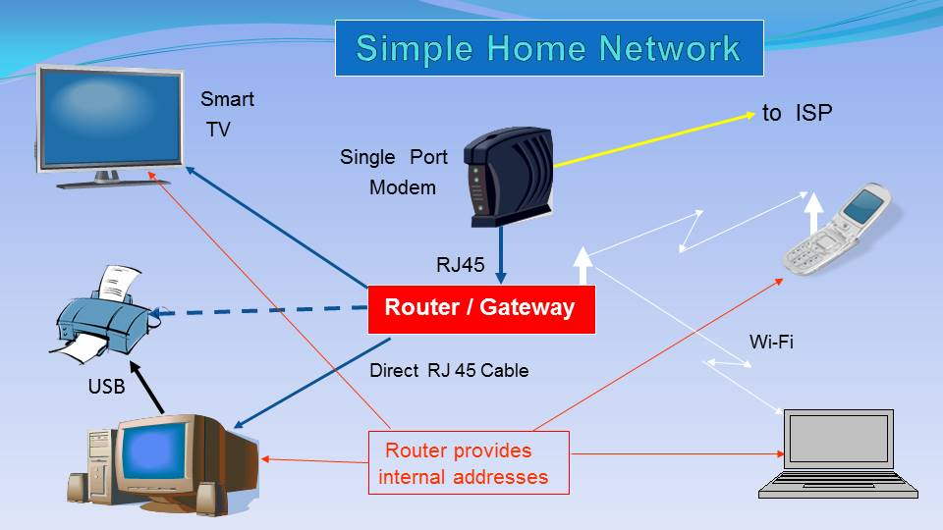

Next Month - Christmas BBQ, note – staying with 3rd Sunday (ie. 18-December)

