Beast Report - 16 October 2016 from Dave Botherway

Usual welcome and check re everyone getting their emailed Meeting reminders OK . .

Questions answered were :

Query re OneDrive Security - be sure to have alternate email address registered with Microsoft and also to have mobile phone registered for “two factor authentication” Suggested that key data be also stored locally offsite (in case of any access problems as with the MegaUpload forced shutdown in 2012)

Concern that a Livemail backup was unreadable. Explained that as an export, it would have an internal format intended only for a corresponding import.

Two Scam warnings:

an Aust-Post arrival notice, from margaritakoldsd @ mail .ru The .ru (Russia) being a critical warning !

Another pretending PayPal scam, offering an October Statement

MelbPC Committee Election

As Returning Officer, Dave explained the overall process and Ballot Paper format

Closing deadline being 4pm, Monday 31-October via PO Box 176, Vermont.

Interesting Videos :
- As followup to last month’s Air New Zealand OnBoard Safety videos using Hollywood actors, this version showed ‘body painted’ crew members to get traveller attention.

Main Topic
- RAM Drives – What, Why, How ? see attached PDF file . . .

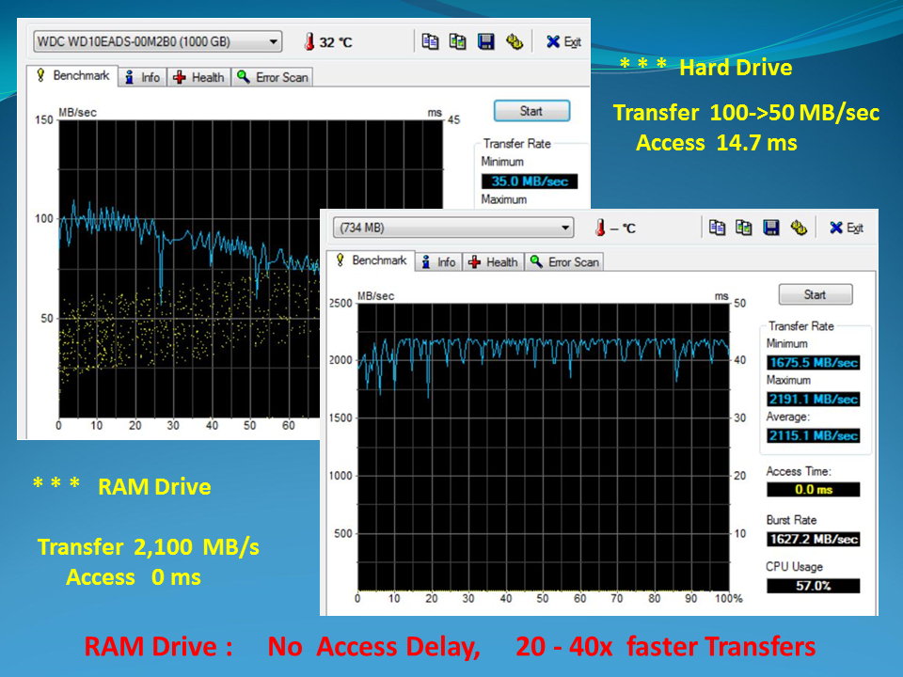

Next Month - Home Networks : What, Why, How !

