Beast Report - 19 February 2017 from Dave Botherway

Welcomes : Welcome back to Bryan Paten, after 3 weeks in Hospital

Website: A BEAST website now exists (as part of MelbPC SIGs section, with URL http://www.melbpc.org.au/interest-groups/eastern-suburbs/beginners-east-beast-sig/
It lists past12 month’s meeting reports and PDFs of most past presentations . .

Buying : Dave showed a Fit-Bit equivalent watch, $35 on eBay received 3 days ago, intended for measuring pulse rate when exercising. Connects to mobile phone using Bluetooth, but too early to gauge effectiveness of watch and phone app.

Questions ‘in-advance’ were:

On member having an annoying PopUp message Shortcutlauncher.exe-application error. While Google states it is a Registry error, it was suggested that the usual CCleaner Registry Scan be run. NB. Later feedback stated still occurring ! !

Confusion over USB types ? Diagrams used in Slide show to demonstrate the various types and differences.

Main Topic

- NBN – looming for all of us, with more details and discussion next month

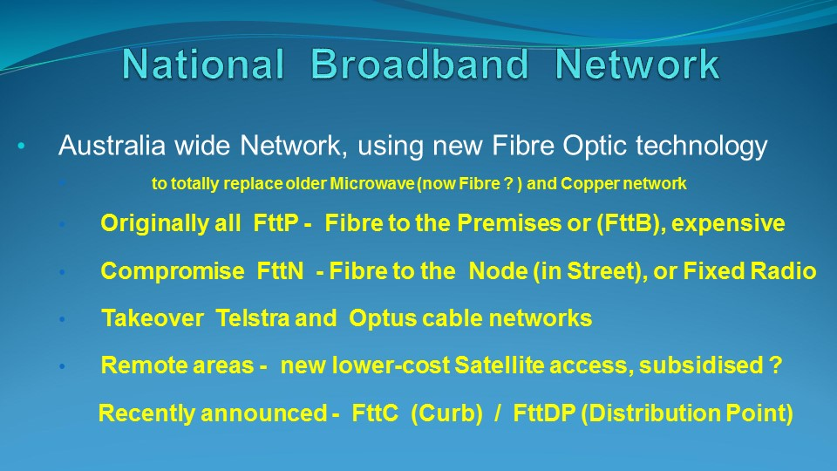

NB. No meeting in April – as third Sunday is Easter weekend

