Beast Report - 18 June 2017 from Dave Botherway

Buying : No one spending . . . and Tax year concluding soon !

Malware Updates :

Being near End-of-Financial year, watch out for bogus emails . . . .

Company Dividend Summaries
  - Tax Agents, such as HR Block
  - ATO letters
  - Health Insurance “better offers”

Also be on the watch for bogus NBN offers – via phone or email

Useful video from Sophos - explaining phishing methods and precautions needed

Similar warning video from eSet - explaining Ransomware . .

NBN Update:

NBN saying for DB - “There’s still work to do before we connect your premises”, but neighbours also currently on Optus being told – “Great news, you can now switch to the nbn™ network” . . . .
Watch this space . . .

Main Topic :
- Windows-10: the different editions – Home, Pro, Enterprise, Education
- The different versions - check via Settings / System / About, shown below.
- Discussion followed re progress of members, and advantages of later versions . . .
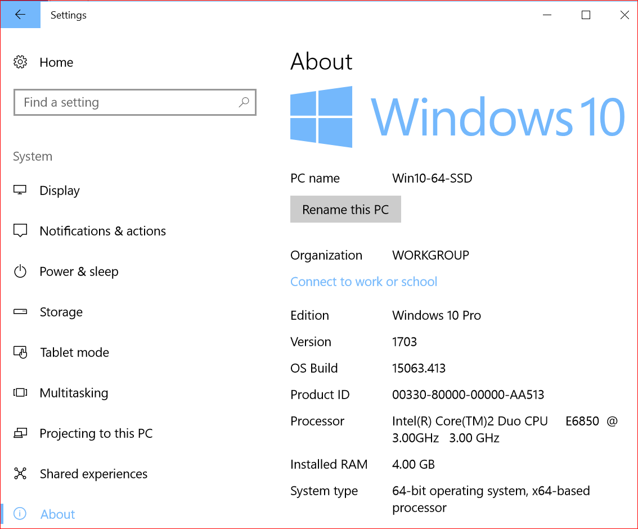 | 