Beast Report - 19 March 2017 from Dave Botherway

Buying : Dave updated us re his Fit-Bit equivalent watch - $35 on eBay received last month. He was able to show recorded results and a close comparison with a walking / mapping app re distance travelled. Overall reasonably effective, but awaiting a more comprehensive version – supposedly measuring Blood Pressure !

Recent email scams :

Some BEAST members had received an email supposedly from Rob-S. However the strange Canadian source address confirmed the scam nature ! !

We also demonstrated and explained how another MelbPC member's friends on his address book were now receiving scam emails, from someone else on his list.

Questions ‘in-advance’ were :

What is Sandboxing – and how to use it . . See APC Magazine March2017 or earlier description at http: //apcmag.com/sandbox-for-security.htm/

When opening a Word document with an inserted photo, is there a way to not have the protected view default ? Problem shared, but no obvious solutions . .

Main Topics :

- New version of Windows 10 (v1703, Creators Update) looming. Expect it to be a 3+ GB download, and to take 2+ hours to process.
- NBN Update - More discussions including the Optus “30-days” shutdown letter, once NBN is available in the area of those currently using Optus cable.

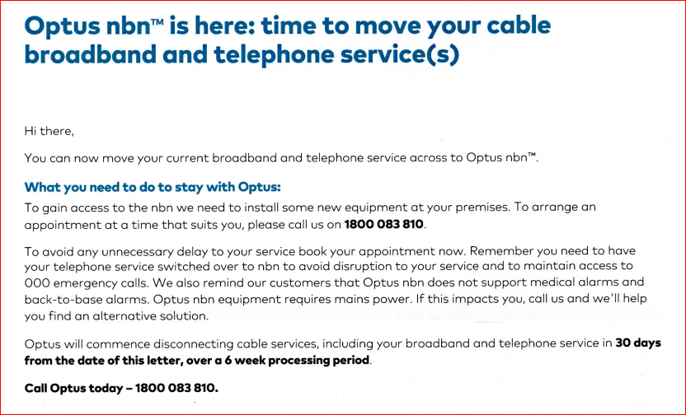

NB. There was no meeting in April – as third Sunday was Easter weekend

