Beast Report - 15 April 2018 from Dave Botherway

Welcome to all – and apologies re Email Reminder problems caused by a Server change over the Easter weekend . .

Buying :
One member having a new PC built for him - usual quandary, higher cost that expected due to “store suggestions” (Do you want fries with that . . )

Brian-H gave a great demonstration of the setup in stereo of two Sony XB10 bluetooth speakers,

Questions :

What is Firmware – for my printer ?

Three components . . . . Hardware – the physical bits, Software (including drivers) that run on the PC and Firmware – embedded microcode that runs on the hardware. Thus for the printer, the manufacturer has issued as update for the code stored and run on the Printer.
Similar firmware exists on PC motherboards (bios), routers and mobile phones.

Current Scams :
Further warnings from - www.staysmartonline.gov.au Recommended reading for all.

Interesting Videos :
Toyota installing Amazon-Alexa as voice-activated digital assistants in new Lexus cars ! !

Macrium Reflect Backup :

The recommended product (free) for backups of home PCs

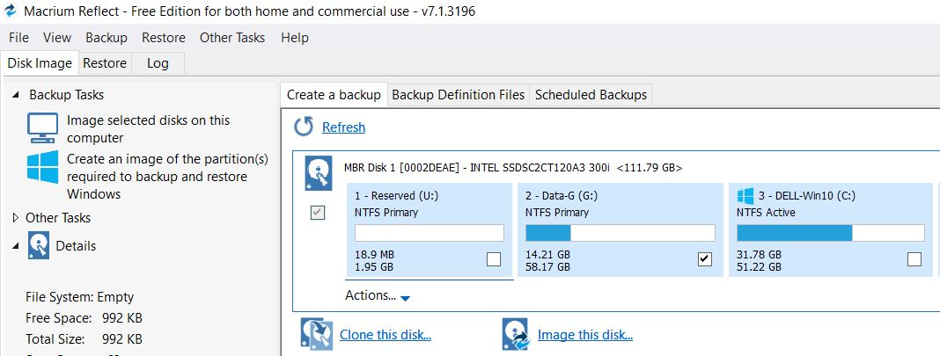

Clone this disk – used when copying to a replacement hard drive (or SSD).

Image this disk (or partition) - creating a full image (preferably to an external drive) that can be used to restore the original drive (or partition) should it be corrupted, or to restore individual files . .

