Beast Report - 15 October 2017 from Dave Botherway

Purchases :

Only one person buying things – rest must be saving for Christmas . .

Questions in advance :

Missing columns on Windows Live Mail ? Solution is to Click on the Headings bar (eg. From ) – and then chose desired columns. Also applicable within File Explorer as below

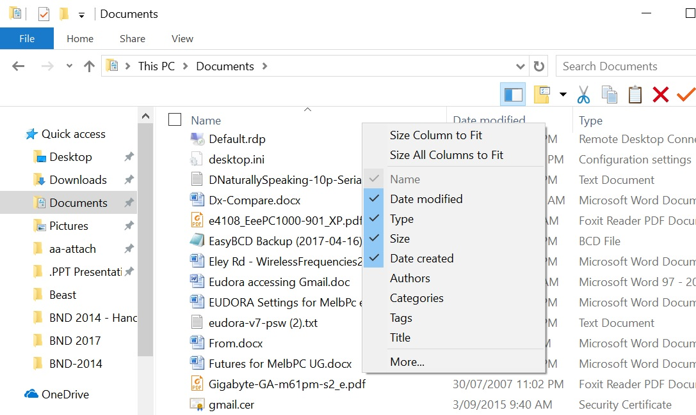

Scams / Cautions :
Current spate include Aust-Tax-Office refunds, usual Bank ‘Acct locked’ or ‘You need to update your details’ and from ‘retail stores’ - ‘You have been chosen for a $2000 gift card’

The Government Stay-Smart-Online is also currently warning us of scams ‘from eBay’ about Unpaid invoices and Voice Messages – Click to Listen ! They are also warning us about AusPost and e-Toll messages – asking to ‘Click on OneDrive to get details’ For warnings, see
https://www.staysmartonline.gov.au/ (maybe subscribe for regular updates) , , ,

Melbourne PC User Group Web system

One of the key changes needed for our User Group is a revamp of our Office Services and Website. A video from John Hall was used to demonstrate how members should use the self-service to update their details, renew membership and subscribe to SIG meeting reminders.

Managing Images within Emails . . .

Dave demonstrated the two methods of adding images/pictures – either INSERT in body of message (with some email clients having trouble with oversized images) or ATTACH externally. His preference – external attachments as easier to manage .

Reminder November and December Meetings

As DaveB has an SES activity on 18-19 November, we will have an external presenter extolling the value to Member of the MelbPC Yammer application.

For December, our meeting with BBQ lunch is on the SECOND Sunday – ie 10 December. Mark your Calendar – more details later . .

