Beast Report - 10 December 2017 from Dave Botherway

Questions in advance :

What is the difference between Google and Google Chrome ? Key difference is that Chrome is a HTML browser (as is Internet Explorer, Edge, Fire Fox, Opera etc), whereas Google is a search engine (as are Bing, Duck Duck Go etc) that run within a browser. The confusion comes from Chrome and Google being products of ‘Google Corporation’.

I have tried to save / download web pages for later use, but unable to display. Key is when saving web pages (‘save as’ Webpage complete) there are two key parts: firstly a URL file, that then accesses a sub-directory when all the needed components are stored. As the URL links to the subdirectory, both parts ate needed in the original “save” location for it to work.

NBN Update :

With most houses in South east Melbourne due to get NBN services via HFC (Hybrid Fibre Coax), it is interesting to see the latest statements . . .

While most new people to HFC are getting good/satisfactory service, about 15% are having problems – with the % increasing . .

NBN are thus delaying any further new HFC connections after 11 December for 6- 9 months so that they can ‘improve customer experience’

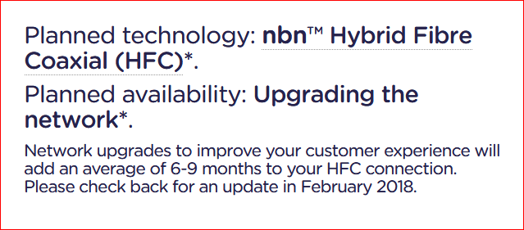

There are many guesses as to what this really means . . .

Building more HFC trunk capacity

Getting better diagnostics tools – for RSPs and Users

Finding a better technology (ie. FTTC - Fibre to the Curb)

Watch this space . . .

With it being our December meeting with BBQ lunch to follow, a shortened agenda applied.
However time for special thanks for those that assist with setup each month (Bryan-P, Clive and Gary), to Choy for organising supplies and to BBQ Chef, Brian-H.

