Beast Report - 18 March 2018 from Dave Botherway

Welcome to all – and an early reminder that the December meeting will stay on normal schedule of 3rd Sunday, ie 16 December . .

Buying :
No one buying - must be saving money for Easter presents . . . .

Questions :

How to self-subscribe to the BEAST email reminders list ? Signon to Melbpc.org.au / Members Area / then via Dashboard, use Join Groups section . .

How to access / download PC Update (now that it has changed since last year). To be demonstrated next month . . . . .

Current Scams : Emails offering job hires, Tax Office demands (needing payment by Bit Coins !) plus requests from ‘Microsoft’ to revalidate Office-365 signons ! A video showing extent of Google Tracking via mobile phone – scary !

Default File locations – are separate for each user is area C:/Users/username/Documents etc
However many prefer to have their Documents, Pictures, Music etc on a separate drive . .
See steps as follows . . .

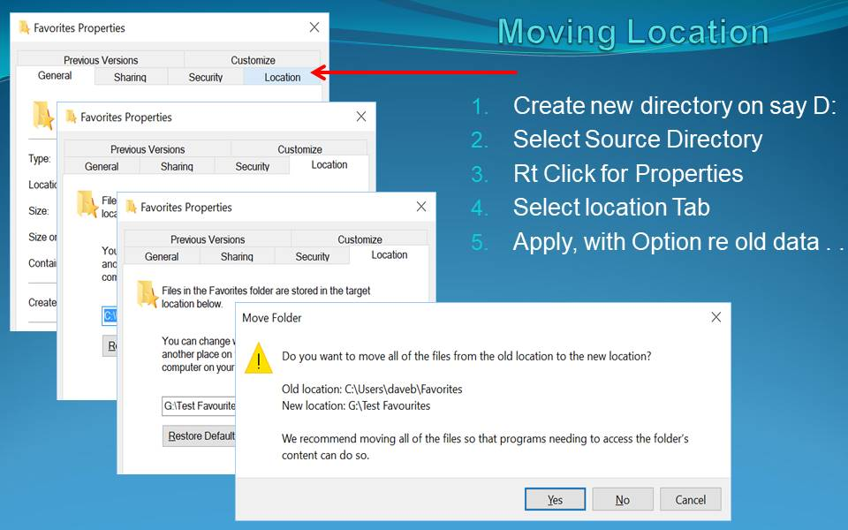

Setting up a new Facebook account:

Key elements - ensure maximum privacy options selected. A great guide being available at :

https://www.techlicious.com/tip/complete-guide-to-facebook-privacy-settings/

Biggest issue is educating/controlling ‘younger’ and ‘much older’ people of the many perils !

