Beast Report - 15 July 2018 from Dave Botherway

Questions :

Whereas NBN-FTTN (Fibre To The Node) performance reduces with distance, what is the effect of distance with NBB-HFC ? In essence, HFC does not degrade with distance – however due to media sharing, there can be traffic and signal strength conflicts, the latter resolved using amplifiers.

A problem where FireFox is now opening with a NetBank page. Resolved by resetting the Home Page via Settings menu (pancakes top right), then Options, then Home to reset desired start page.

It is said that monitor blue light before retiring at night can make it harder for people to sleep. A new feature within Windows 10 allows the blue content to be reduced. Go to Settings / System / Display to set appropriate ‘less-blue’ colours and desired hours for them to be used.

Latest Scams :

Given tax-time, Stay Smart Online (at https:/www.staysmartonline.gov.au) are warning of “MyGov emails” promising ATO tax refunds and seeking bank acct details.
Another good warning site is https://www.scamwatch.gov.au/news

Similarly Crikey at https://www.crikey.com.au/prying-eyes/ is a great site for both reporting both scams and ways personal surveillance information is being obtained about us 24/7 . . .

Main Topic - Cloud Storage:

Microsoft’s One Drive is now a key component of both Windows 10 and Office-365 – providing cloud storage of key data and ability to sync across multiple devices, and share data using controlled links sent out via email. A great video explaining this is at

https:/www.youtube.com/watch?v=ZZwmxUgSfZM

or for more details, see https://www.youtube.com/watch?v=197fqlNjVgk

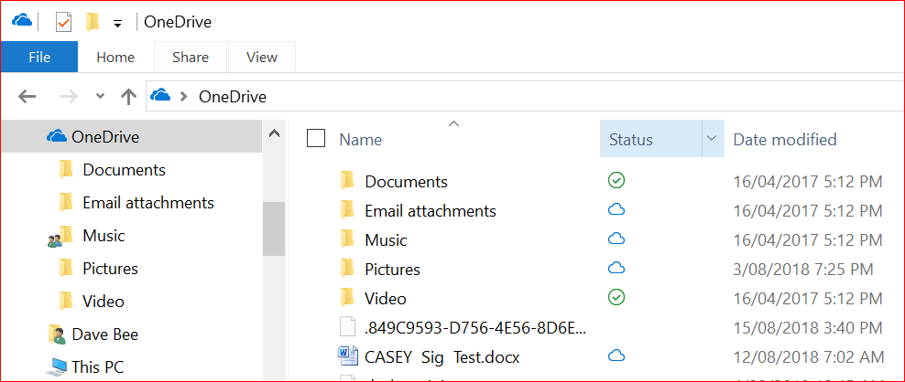

Similar functions exist for DropBox and Google Cloud . . Enjoy, daveb..

