Beast Report - 18 November 2018 from Dave Botherway

NBN Progress :

Dave had finally got a flood of letters offering NBN – the key one being from NBN-Co saying NBN is now available at his address and that existing services will be “disconnected from 8 November 2019”.
But yet to hear specifically from existing supplier (Optus-Cable) as to their cut-off date – rumoured to be only three months - - - - - Watch this space . . .

Questions :

Further to discussion last month re Email Delivery Receipts - while sender may request a receipt, receiving client software or recipient may have it blocked. Thus NOT getting a delivery receipt may not indicate Non-Delivery . . .

Back in the days of Windows 7, there was a very useful tool ‘Windows Experience Index’ that gave ratings on the components of a PC (ie. Memory, Graphics, Disk speed etc). While there is no easy access to this data is Windows-10, the info can be obtained using a free third party tool – WinAero WEI ..

Interesting Videos :

“ Millennial Job Interview ” - exposing the generational gap between and employer and a far-younger possible recruit . . See https://www.youtube.com/watch?v=Uo0KjdDJr1c

Main Topic : Office-365 . .

The various Microsoft Office editions were explained – including both classical desktop versions and the Office-365 cloud-based options available as part of MelbPC membership.

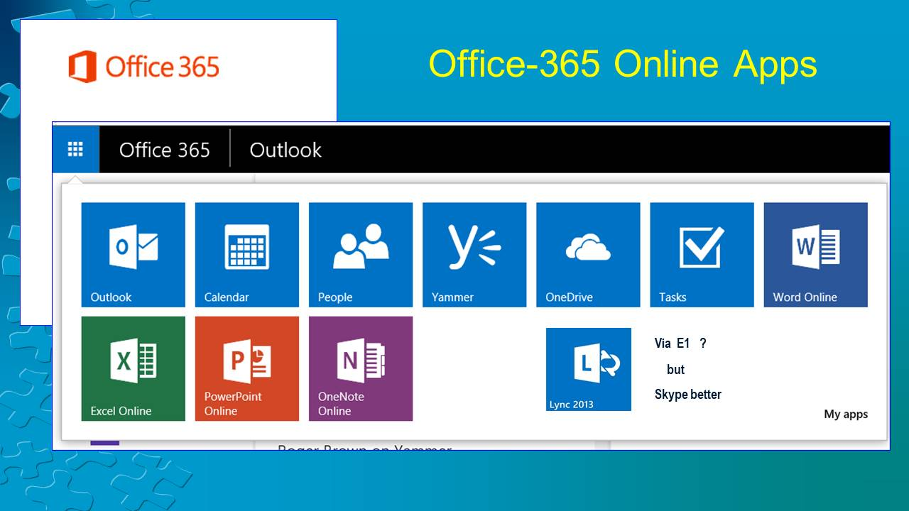

For those still seeking a desktop version, MelbPC members can get Office-365-Desktop (for up to 5 PCs) via an addon charge of $65 pa - comparable to retail cost of $119 pa.

