Beast Report - 19 May 2019 from Dave Botherway

Buying :

As part of his Optus HFC-NBN deal (as installed on 21-March), Dave has taken up the free FetchTV addon. Works great, but awaiting billing: suspect may be problems.

Questions :

What is difference between Video Streaming and Video Downloads ? Streaming is a broadcast method with immediate display but little ability to correct incomplete sections and may not allow file saving, where Downloads will resend errored sections, but may need to wait till whole file downloaded to display content.

How does fixed Wireless Internet compare with Fixed Line Internet ?

Fixed line use a physical connection to subscriber premises – via coax cable (HFC), existing phone line (FTTN, FTTC, FTTB) or for some lucky people, fibre (FTTP).

Where these methods are impractical, NBN may offer Satellite (max 25 Mbps) or Fixed Wireless (max 50 Mbps). In each case, a special aerial is placed on the subscriber’s roof aligned to either NBN satellite or a local Fixed Wireless tower . . .

Scams : www.StaySmartOnline.gov.au has multiple warnings :
- Phone messages purporting to be from ATO (relevant at Tax Time)
- Phone scammers impersonating the Australian Cyber Security Centre
- Exposure of Windows-& and earlier, needing latest security update.

Main Topic : VCRs, PVRs – what are they ?

VCRs (Video Cassette Recorders, probably using VHS tapes) have been replaced by PVRs (Personal Video Recorders, using Hard Disk or USB storage) - both allowing recording of TV shows and later playback.

One such PVR is Fetch TV, promoted by Optus and other ISPs/RSPs (Dodo, iInet, iPrimus) as part of an Internet package or the box can be purchased from Harvey Norman, JB HiFi etc. A video showing the Fetch functionality was shown – it being representative of many of the PVR currently available . .

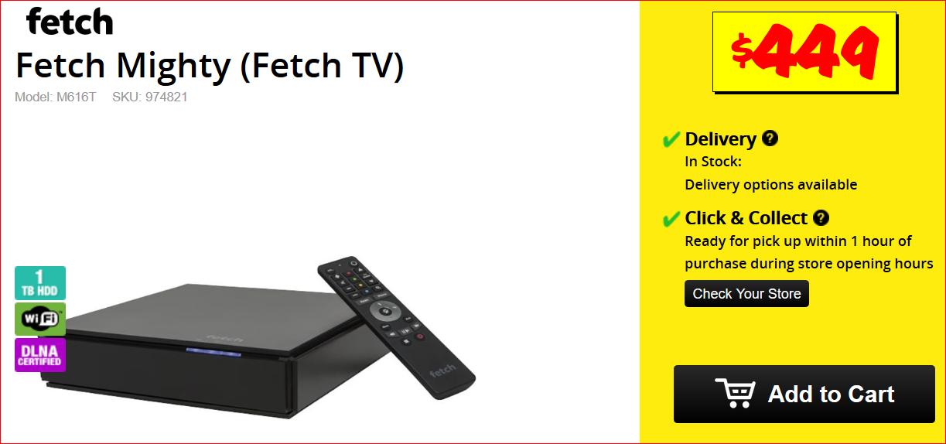

Next Month . . .

File History & Timeline – new components of Windows 10 ... (to be confirmed)

