Beast Report - 16 June 2019 from Dave Botherway

Buying :

Now that his Optus HFC-NBN is running OK, Dave has received billing overcharges – that eventually resulted in a credit of $27 more than requested. Watch this space !

Questions :

Windows Update KB4494441 is showing as installed twice ? A Google search indicates that this is a known problem – without any adverse effects . . .

Windows is now providing some great photos as wallpaper for the Signon screen – how can we access those photos ? To find the photos, first change Explorer via options / view / Show hidden files, then go to

C:/users/aaa/Appdata/Local/Packages/MSWindows Content Mgr etc/ LocalState / Assets . . The photos will show with long strange names – rename to jpg and enjoy !

Alternatively, having set to show hidden files, do a search for the Assets folder . . .

Main Topic : File History and TimeLine . .

The Windows File History backup was first introduced in Windows 8.1 – but often overlooked. To use it, go to Settings / Update&Security / Backup / More options.
Very useful for automatically copying files from selected directories to an external backup device.

Timeline is a graphical feature provided in Windows 10 v1803 onwards, that tracks files used in last 30 days – possibly even across multiple PCs for the same User ID . .

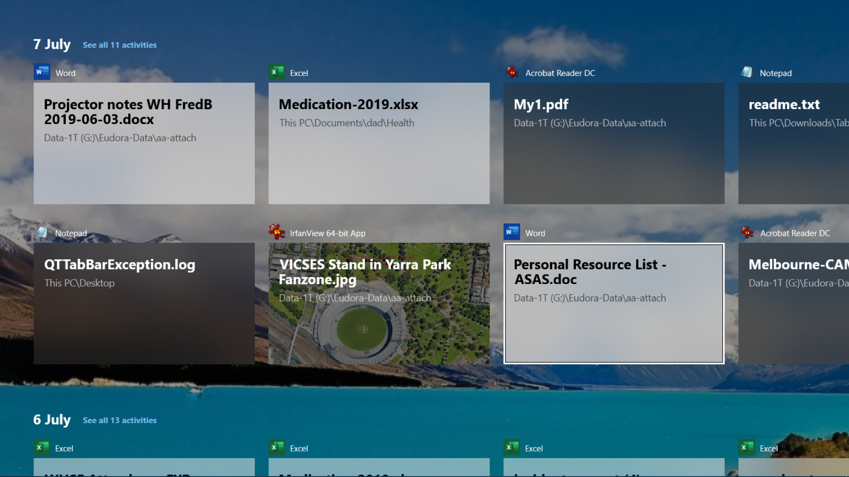

Next Month . . .

Windows Email vs Office Email : Win10 components for all MelbPC Members ...

