Beast Report - 15 Sept 2019 from Dave Botherway

Questions :

“ If I have several files in one folder and I want to arrange those files again in separate folders, what is an efficient way of saving my files and getting rid of the folder ?” Suggested method is to open two copies of File Explorer (or use a dual pane app such as Salamander) then use Drag&Drop to move the files.

“ When I receive junk email in Outlook, I block it and delete it. However, it seems Outlook is not blocking it because it keeps coming back ! ” In many such cases, the “sender” changes for each message – thus being a new “sender”, it gets through. Check the sender addresses.

Data Security Methods – a broad ranging topic to be covered over future meetings . .

NBN - FTTC :

With some members soon to get Fibre-to-the-Curb, the diagram below explains the setup.

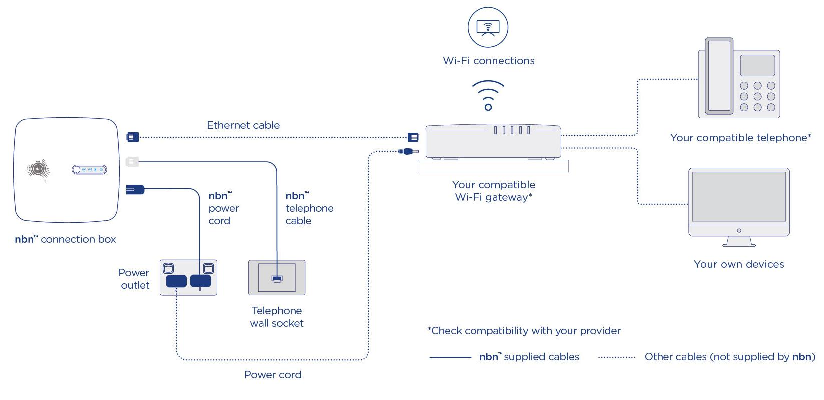

Main Topic - Virtual Private Networks

As part of Data Security, VPNs were discussed – key point being exit from VPN provider to information source is not protected . . .

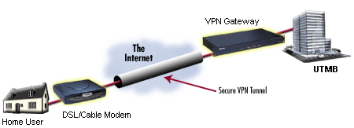

Special Apps at each end to encrypt the data
Corporate
Site
Modem

Next Month . . . Windows OneDrive

