Beast Report - 20 Oct 2019 from Dave Botherway

A delayed start due to a projector problem – later found due to bent pins in the HDMI cable !

Questions :

“ How can I decrease the Windows startup sound – so loud, my dogs runoff as soon as I start the PC ? ” Maybe “Open Volume Mixer” from the RHS of taskbar and reduce volume of System Sounds. Discussion indicated this did not work. Other suggestions welcomed !

“ Could the new 5G be an alternative to NBN ?” A broad topic to be considered next month.

Because of time lost due to the projector delay, other questions deferred till next month.

Emergency Plus App :

 | Brian Heywood demonstrated this very useful App, available from :  https://emergencyapp.triplezero.gov.au/  Key points – App provides appropriate Emergency phone numbers and Lat/Long co-ordinates, so that current location can be advised.

Windows One Drive

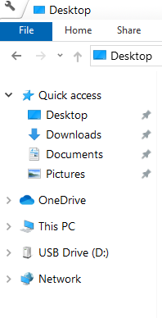 | A key part of Windows is One Drive – an extra directory where user data placed there will be easily copied to “the cloud”. It can then be synchronised across multiple devices and selectively shared with other users, via email advice . . . .  For basic users, one GigaByte (GB) is provided free – but for MelbPC members using Office-365, one TeraByte (TB) is provided as part of the subscription.  ( 1 TB = 1,000 GB, 1 GB = 1,000 MB ! )  Note : Drop Box provides 2GB free, then $185pa for 2 TB.  Google Drive – 15 GB free, then $44 pa for 200 GB.

Next Month . . . Data Security – Passwords, 5G as NBN Alternative ?

