Beast Report - 15 March 2020 report by Dave Botherway

A smaller attendance – probably due to of health concerns of coronavirus, COVID-19

Everyone reminded re need for Washing Hands and extra care if sneezing. Agreement that a decision re April meeting to be delayed till closer to that date.

Questions :

For an external drive needing to appear as Drive-E, I cannot manually assign it (via tool Disk Management) to it’s usual letter E – says E not available. Suggested solution: via Disk Management, find out what device is already using E (maybe a USB stick), reassign it to some other letter, thus allowing external drive to take the usual E allocation.

I have just downloaded Ashampoo Photo Optimizer 2019. However, when I clicked to open it, I got a message saying “Revocation information for the security certificate for this site is not available." While a Google search offered a Internet Explorer solution, my preference is FireFox - What can I do ? While the suggestion was to initially just try a different browser, the problem solved itself following a PC reboot. Worthwhile noting that a reboot can often ‘fix’ many things !

Scam Alert :
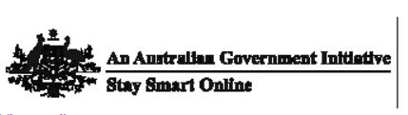  An alert from Stay Smart Online - - where scammers exploit the current COVID topic.  Usual recommendation – DO NOT OPEN | 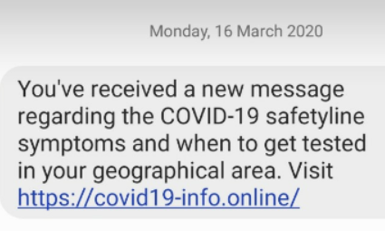

Windows 10 Tips

- If text etc on screen is too small, go to Settings / System / Display, set Scale and Layout to say 125% . .
- To change Screen background picture, go to Settings / Personalisation / Background and choose different picture.
- If low on disk storage, use File Explorer to go to My PC on Left panel. Then Right Click on C drive in Right panel – to bring up many options. Select Properties option at the bottom. Select Disk Cleanup button, then Clean up system files button. It will show amount of space that can be saved, so select areas to be cleaned and press OK. May take some time, watch progress bar . .

Next Meeting . . . Sunday 19-April – maybe . . .

